VZLU - Czech Aerospace Research Centre
Aviation Division - Materials and Technologies Department
Materials Testing Laboratory

PULL-OUT TEST

Tensile Machine: Inova ZUZ 50
Material: Prepreg Nanopith ER130_90 / CC200T300 3K Plain
Foil adhesive Scotch Weld AF163-2K WT 0.06
Honeycomb Plascore PAMG-XR1-3.1-3/16-10-P-5056
Adhesive for inserts Araldite AV138M/HV998MP
Set: V43b
Test method: Pull-out (ECSS-E-HB-32-22A)
Crosshead speed: 0.5 mm/min
Test date: 20. 5. 2020
Operator name: I. Mlch
Temperature: 26.1 °C
Humidity: 36.2 %R.H.

 | Sample | Max. Load | Note
 |  | (kN)
1 | V43b-1 | 2.333
2 | V43b-2 | 1.727
3 | V43b-4 | 0.541
Mean |  | 1.534
S.D. |  | 0.912
C.V. (%) |  | 59.46
Min. |  | 0.541
Max. |  | 2.333

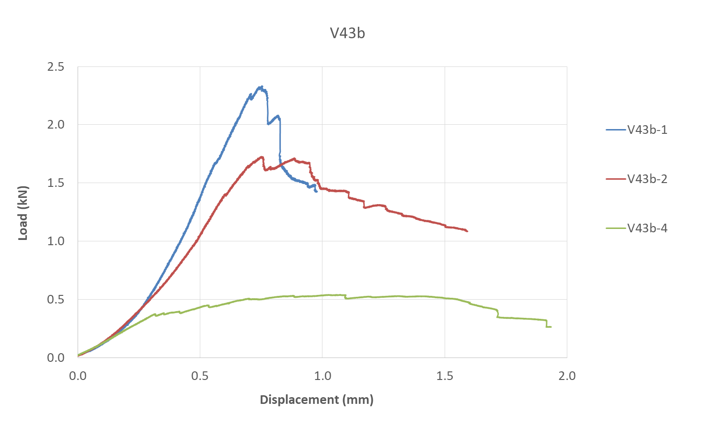

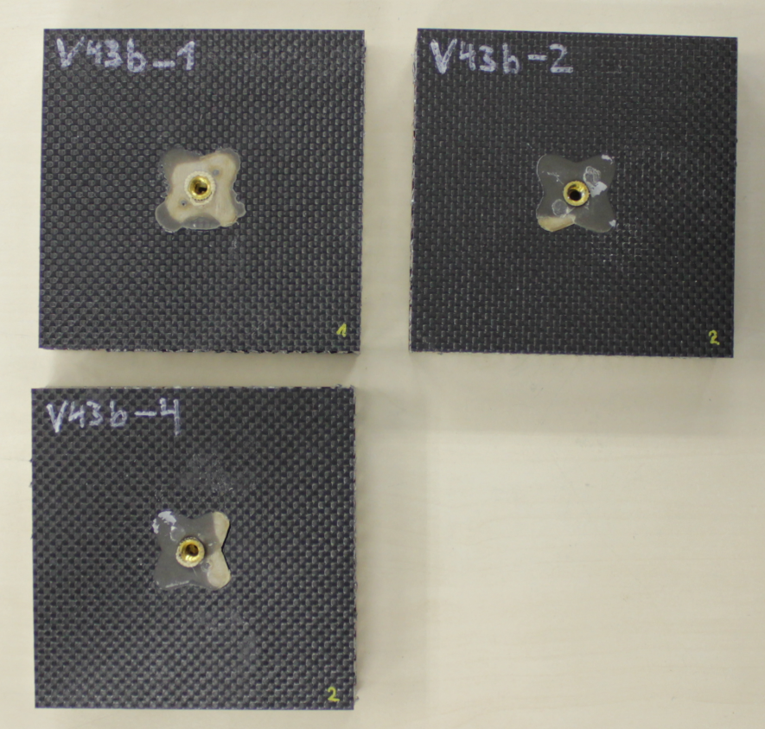

Fig. 1 – Specimens before testing

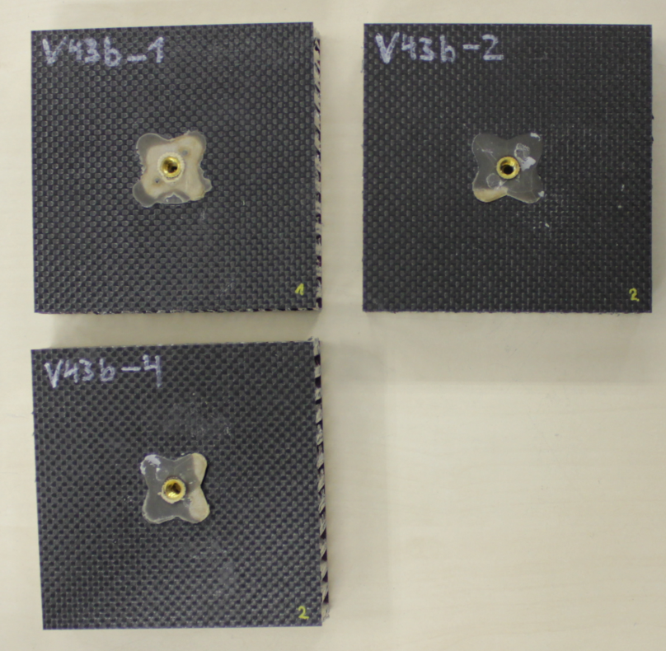

Fig. 2 – Specimens after testing

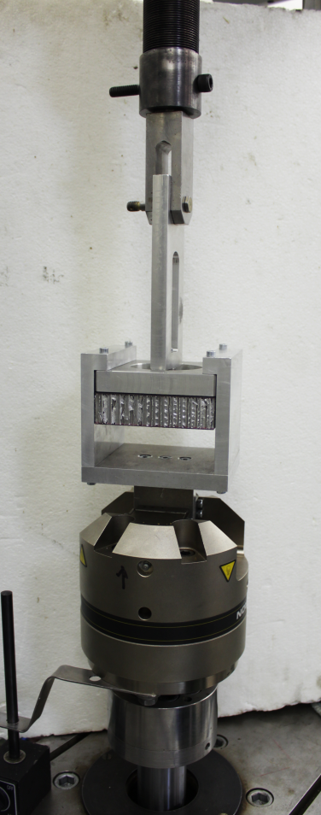
Fig. 3 – Test setup overview

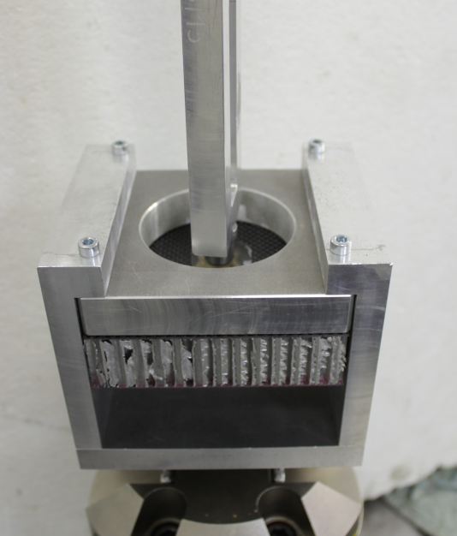

Fig. 4 – Specimen clamping detail

End of record

